THE KIDS REACHING KIDS MISSION OFFERING PROJECT

MINISTRY OVERVIEW/ACTION PLAN APPLICATION

2020

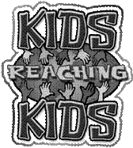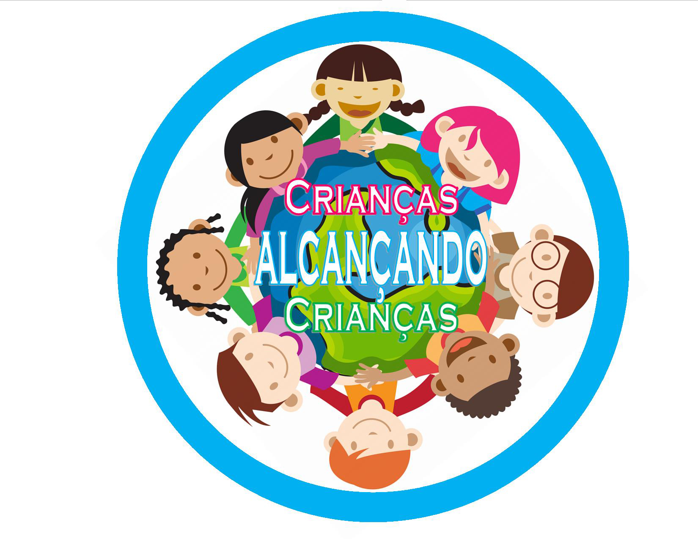

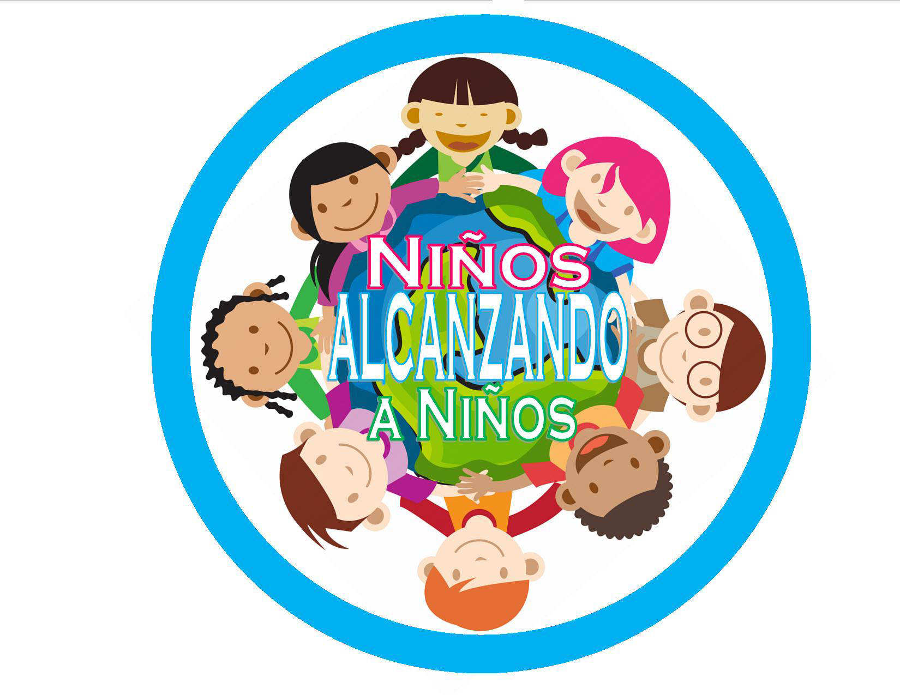

Section 1 – Kids Reaching Kids Holistic Approach

The Kids Reaching Kids Mission Offering Project is the annual children’s mission offering emphasis. The money from this offering funds varied projects, including a major focus each year.

Kids Reaching Kids believes the lives of children are impacted most effectively by a holistic approach. A holistic approach impacts lives mentally, physically, spiritually and socially.

- Mentally through education to children’s minds.
- Physically through compassion to have children’s basic needs met.
- Spiritually through evangelism to reach children for Christ.
- Socially through discipleship to strengthen children’s faith.

This holistic approach is biblical and is modeled in the life of Jesus. Luke 2:52 reveals how Jesus’ life was shaped in a holistic fashion.

Jesus grew in wisdom (mentally) and stature (physically),
and in favor with God (spiritually) and men (socially).

Section 2 – Review of Recent Kids Reaching Kids
Mission Offering Projects

The Kids Reaching Kids Mission Offering Project has helped to meet the holistic needs of children around the world. Some recent offerings that reflect this holistic approach include:

- Mental (Educational) 2020 Discipling the Disciplers of Children – providing the disciplers of children with the needed resources and experience to fulfill God’s mission in their church and communities.

- Spiritual (Educational) 2019 Kids of the Word – for resourcing Children’s Bible Quizzing around the globe.

- Spiritual (Outreach) 2018 Fall Like Rain – for Bible translation, evangelism, education, and discipleship in our world areas.

- Physical (Compassion) 2017 For Our King – for refugee and immigrant children caught in the middle without life-sustaining resources.

- Mental (Educational) 2016 POWER – to help combat biblical illiteracy by equipping children with God’s Word, while also educating children about the importance of spending time reading the Bible and listening to biblical teaching.

- Physical (Compassionate) 2015 In His Name – for regional, district, and local efforts of ministry toward children with special needs.

- Spiritual (Evangelism) 2014 Listen, Learn and Let it Out! – for the purchase of audio Bibles and for other orality ministries focused on children.

- Mental (Educational) 2011 Mission STAR Quest: Supplying Totally Awesome Resources – provided school supplies and materials for Christian Schools and Child Development Centers (CDC’s).

Project years with depleted funds have been removed from this form.

KIDS REACHING KIDS

MISSION OFFERING PROJECT

ACTION PLAN

Global Region:

Regional SDMI Coordinator:

Regional/District/Local Ministry Director:

Address:

Telephone: Fax:

Email: Mobile Phone:

- Action Plan Summary:
(Statement of the main ideas, the problem/issues, necessary background information to understand the problem, a description of any alternatives, and the major conclusions. Please be brief.)

- PROJECT DETAILS

- PROJECT DESCRIPTION

- GOALS AND OBJECTIVES

- PROJECT’S RELATION TO WHICH HOLISTIC APPROACH

- AMOUNT OF FUNDS REQUESTED $ USD

- THE TIME FRAME OR TIMELINE OF THE PROJECT
Proposed start date or date started:
Evaluation/review date(s):
Other stage(s), milestone(s):

- TARGET CLIENTS
(The population this project will serve to include estimate number of children to be positively affected and served by the project.)

- MONITORING AND EVALUATION SYSTEM
(What system does the project put in place to monitor and measure the progress?)

- NAMES AND CONTACT INFORMATION OF KEY INDIVIDUALS RESPONSIBLE FOR IMPLIMENTATION OF ACTION PLAN

Submitted by: ___________________________________ Date Submitted: __________

Approved by:

*District SDMI Coordinator

District Superintendent (copy in)

*National Ministry Coordinator

*Field Strategy Coordinator

Regional SDMI Coordinator

Regional Director

SDMI Global Director

*Optional Approvals, determined by the Regional SDMI Coordinator

The KRK MOP Action Plan must be submitted and approved by Sunday School & Discipleship Ministries International before any funds will be distributed to the world region.

