“JESUS IS LORD”

Quadrennial Address

David A. Busic, Chair

On behalf of the
Board of General Superintendents

29th General Assembly
Church of the Nazarene

Indianapolis, Indiana, USA

26 June 2017

© 2017 Church of the Nazarene Inc.
All rights reserved.

Introduction

The Church of the Nazarene was born from a series of mergers among holiness-minded churches and associations between 1907 and 1908. The first merger took place in the U.S.A. when the Church of the Nazarene, from the West Coast, merged with the Association of Pentecostal Churches of America, primarily from the East Coast. One year later the Holiness Church of Christ, from the South, joined them for the unifying General Assembly at Pilot Point, Texas.

The spirit of that union was palpable.

At a critical moment, Bud Robinson, fondly referred to as simply “Uncle Buddy,” turned to the chairman of the assembly and said: “Dr. Bresee, we have been one all the time but we just didn’t know it. Now that we have found it out, it is still time to say so. I would like to make a speech, but that would delay the vote and I want to vote. I want to shout ‘Aye.” I want to raise both hands; I want to march around and celebrate. I want to make it known in three worlds that the Nazarenes from east, west, north, and south are one. Can’t you hurry us along, Doctor, and let us celebrate?”

And so they did. They voted unanimously and enthusiastically: “Yes!” And then they marched around the tents as a sign of their unity and confidence that God was with them.

These diverse groups were able to unite because they steadfastly agreed on the possibility and necessity of personal and corporate holiness, a shared passion for evangelism, and many other theological beliefs. They greatly differed, however, in many other ways: governance structures, leadership styles, sacramental practices, and even particular ethical convictions.

These regional differences threatened to undermine the initial harmony that birthed the Church of the Nazarene. Recognizing this impending threat to unity, general superintendents Phineas F. Bresee and Hiram F. Reynolds prayerfully sought to integrate the varied groups around a common cause that would supersede the differences. Their unifying purpose, their “watchword and song” became, “We will be a holiness and a Great Commission church.”

We would not HAVE a mission; we would BE a mission.

This holiness mission to the whole world gave the Church of the Nazarene a unified trajectory. This guiding principle is what led the delegates of the Twentieth General Assembly in 1980 to embrace internationalization, an ecclesiology that envisions the church as a globally connected and interdependent group “of districts and congregations rather than a fellowship of autonomous national churches” (Ingersol, Past and Prospect, 86).

National boundaries would neither shape nor restrict our global connections, but every local church, regardless of proximity or geography, would be joined together in a tightly knit communion committed to the same mission and message. Early Nazarene pioneers would often refer to it as “the connection.”

It was an “audacious undertaking” (Culbertson). When the predominant denominational pattern was for mission areas in various parts of the world to become independent national churches, we questioned whether or not national boundaries should shape ecclesiological boundaries. We decided the answer was “no.” We chose to pioneer a new path among Protestant churches. We chose to fashion a church that would maintain its democratic ethos of consultation and collaboration, while simultaneously becoming truly international. And it means that the General Assembly of the Church of the Nazarene is likely, according to Nazarene archivist, Stan Ingersol, “the most racially [and culturally] diverse general meeting of any denomination . . .” (Ingersol, Past and Prospect, 86).

As a result, delegates from Africa, Asia-Pacific, Eurasia, Mesoamerica, South America, and USA/Canada, representing 162 nations, 165 primary languages, and 2.5 million members have gathered as ONE in Christ to affirm once again the sacredness of a great global ecclesia.

From this hallowed vision the Board of General Superintendents has chosen as the General Assembly theme: “One Body, One Spirit, One Hope, One Faith, and One Lord.” We are an international holiness communion, made ONE in Christ Jesus!

Welcome and Appreciation

On behalf of my colleagues on the Board of General Superintendents (BGS) I greet you in the strong name of our risen Lord and coming King. We welcome to this 29th General Assembly of the Church of the Nazarene our delegates, distinguished guests, and Nazarenes from around the world who are watching via live stream online. “The grace of the Lord Jesus Christ, and the love of God, and the fellowship of the Holy Spirit, be with you all. Amen.” (2 Corinthians 13:14 NIV)

We first want to express our appreciation to the people of Indianapolis, Indiana, USA, for the gracious hospitality shown to us, especially those from the Indianapolis District for hosting our General Assembly for a sixth time! Our Board also wants to affirm the work of General Secretary David Wilson and his outstanding team for their extensive preparation for an event of this magnitude. We are very grateful.

Many of you made great sacrifices to be here today. You represent a group many times larger than yourselves. We think of the multiplied thousands around the world who would be here if they could. Some of you have come from war-torn, famine-stricken, pandemic-suffering lands where life is difficult and to be a Christ-follower requires great faithfulness and patient endurance. We honor you today and we thank you for the commitments you have made to our “connection.” You have made us a better people. Because of you we are more aware of the moving of God that crosses cultural boundaries and the great communion of the saints we enjoy as the Body of Christ.

The foundation of our work at this general assembly is prayer. The elder statesman of the Board of General Superintendents is General Superintendent Emeritus Dr. Eugene Stowe. He served with distinction for 25 years until his retirement in 1993. He is 95 years young! We have asked him to pray this invocation.

Prayer for the Church and General Assembly from Dr. Eugene L. Stowe.

O God our Heavenly Father,

We come humbly and hopefully into your Holy Presence as we stand on the opening eve of the 29th General Assembly. We beseech you to clothe Dr. David Busic, the Chairman of the Board of General Superintendents, with the presence and power of the Holy Spirit as he presents the quadrennial message from his board. May it sound the keynote of this General Assembly with clarity and unction,

In the strong name of Jesus we pray,

Amen.

Theme

The theme of our General Assembly is taken from the Book of Ephesians. Ephesians was not written as a corrective letter to a specific context such as Corinth or Galatia. It was written to be a guide for all churches everywhere and for all time. It constitutes the foundation of the Church as the Body of Christ.

Ephesians 4, specifically, is Christologically based and missionally infused. It speaks of the unity of the Church because there is one God and Father of all; it speaks of the gifts Christ distributes to the Church to fulfill its mission and build up the Body; and it speaks of the ultimate goal of unity and gifting, which is fullness in Christ. Maturity, or Christian perfection, in the Church is found in no other way.

ONE LORD is the foundation for all oneness.

Christianity is not another religious system. It is not another way to be saved. It is not a different way of being human or of self-actualization. Christianity is about Jesus Christ from beginning to end and everything in between. Jesus is not a way … Jesus is THE way! Jesus is not a truth … Jesus is THE truth! Jesus is not a life … Jesus is THE life!

He is the visible image of the invisible God. He reveals the character and nature of God. He clarifies and focuses the purposes of God.

Jesus is the firstborn of all creation. He is the glue that holds everything together. He is the Author and Perfecter of our faith. He is the Head of the Church. He is first in everything!

He is central and supreme. He is primary … everything else is commentary.

Jesus is Lord!

Who is Lord really matters. If we say “Caesar is Lord,” it means something. If we say “Government is Lord,” it means something. But we proclaim “Jesus is Lord,” and no other.

There are only two rightful responses to that declaration: worship and discipleship. We bow to Him and want to be like Him. We want to do what Jesus does. We want to live as Jesus lives. Jesus must live in and live through His people.

Fundamentally, the great problem of the Church today is that many Christ-followers are not disciples. Discipleship has become “optional” for the more radical among us and this has been disastrous for our witness and for our “life together.”

Sometimes our Christology gets co-opted by our ecclesiology. We interpret Jesus by our view of the Church, and if we are not careful, Jesus starts to look like us. He confirms all our biases and substantiates all our fears. But WE are not Lord … JESUS is Lord. We are extensions of Him, not the other way around. We must repent of any forms of holiness that are contrary to Jesus.

Everything we do as a church must be Christ-centered, Christ-empowered, and Christ-exalting. He is, and forever will be, the best Nazarene who ever lived. That is why we have chosen the carefully worded statement of mission: “To make CHRISTLIKE disciples in the nations.” And that is why we are defined by three core-values: “We Are Christian; We Are Holiness; We Are Missional.”

We strongly reaffirm that mission and commend these values to you again.

Jesus is Lord!

State of the Church

Irenaeus, an early Church father from the second century, said “The glory of God is a person fully alive.” Surely, then, the glory of God is also a church fully alive.

It is a joy to tell you that in our 109th year as a church, it is the consensus of the Board of General Superintendents that the Church of the Nazarene is strong and alive to the glory of God.

The Church of the Nazarene began in 1908 with 10,034 members, 228 churches, 11 districts, and 32 missionaries commissioned and sent to 4 countries (Cape Verde, India, Mexico, and Japan). The total amount raised that year was $140,000 (USD), with $12,000 (USD) being raised to support what was then called “foreign missions.”

Today, the church reports 2.5 million members, over 22,000 organized churches, nearly 500 districts, and more than 700 deployed missionaries serving in 80 nations of the world. We say with John the Revelator: “Praise and glory and wisdom and thanks and honor and power and strength be to our God for ever and ever. Amen!” (Revelation 7:12, NIV).

Each region of our connection has experienced the blessing of the Lord in the past four years. Numbers alone can never tell the full story of the good that was accomplished and the extent to which the kingdom of God was advanced. And we are glad that is true. But holiness people believe that “growth in grace” cannot exist without accountability. So we measure to pay attention to fruitfulness.

Quadrennial Reports from Global Mission Regions:

Africa Region

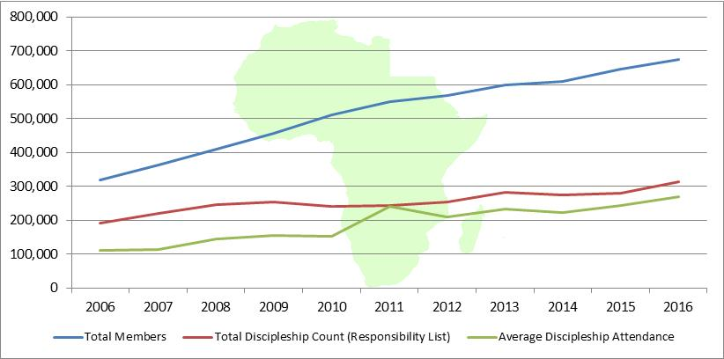

The Africa Region reports 82 different languages are used in its primary worship services.

QUADRENNIAL OVERVIEW: (on-line version only)

- 705 new churches
- 147,062 new Nazarenes
- US$916,951 given to WEF
- 170,768 profession of faith reported
- 76,842 baptisms

Analysis: Nazarene membership growth is widespread in Africa, including new areas such as Benin and Togo, as well as established areas like Mozambique and South Africa.

Asia-Pacific Region

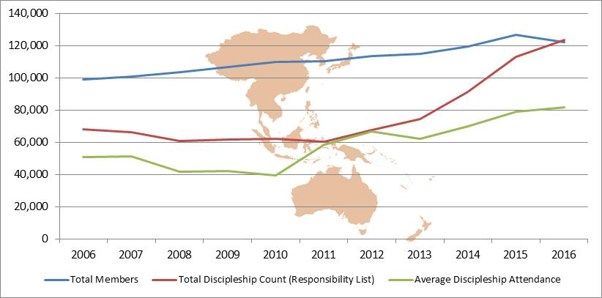

Asia-Pacific Region reports 28 different languages are used in its primary worship services.
QUADRENNIAL OVERVIEW: (Online version only)
- 144 new churches
- 27,241 new Nazarenes
- $1,360,477 (USD) given to World Evangelism Fund (WEF)
- 37,357 conversions reported
- 12,039 baptisms
Analysis: Asia-Pacific’s largest increases are concentrated in Papua New Guinea and the Philippines, though several smaller areas are also doing well. As discipleship enrollment has been emphasized, attendance has also increased.

Eurasia Region
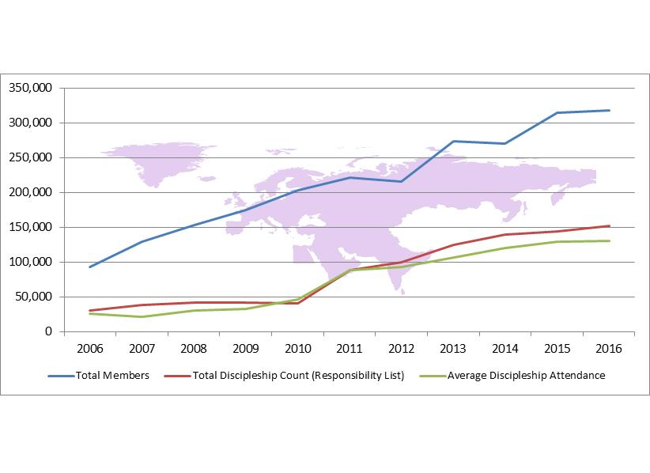
Eurasia Region reports 46 different languages are used in its primary worship services.

QUADRENNIAL OVERVIEW: (Online version only)

- 2,286 new churches
- 107,194 new Nazarenes
- $1,366,992 (USD) given to WEF
- 179,275 conversions reported
- 96,761 baptisms
Analysis: Eurasia’s membership growth has been concentrated in Bangladesh, India, and the rest of the Indian subcontinent. Discipleship is growing, thus membership gains are being consolidated.

Mesoamerica Region
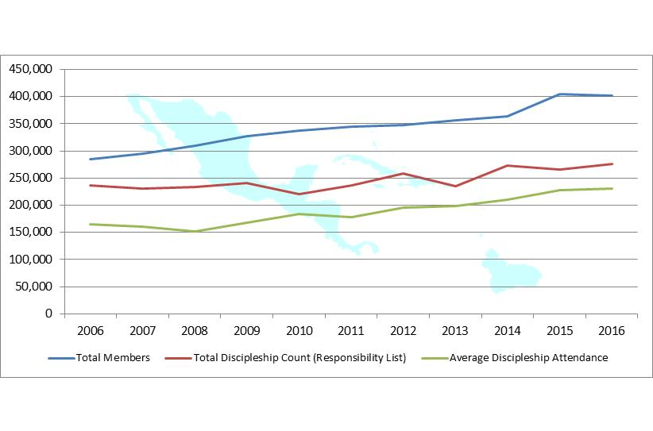Mesoamerica Region reports 13 different languages are used in its primary worship services.

QUADRENNIAL OVERVIEW: (Online version only)

- 305 new churches
- 93,189 new Nazarenes
- $1,710,337 (USD) given to WEF
- 110,369 conversions reported
- 52,132 baptisms
Analysis: Mesoamerica membership growth is largest in the established areas of Haiti, Guatemala, and Mexico, with good percentage gains in the newer areas like Suriname and Aruba. Discipleship attendance is growing.

South America Region

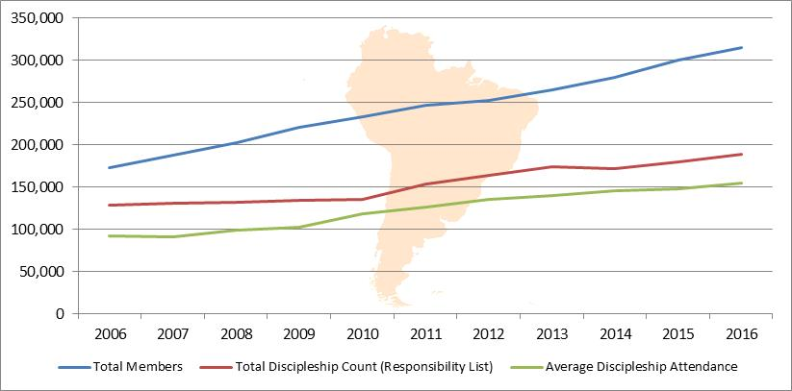

South America Region reports 6 different languages are used in its primary worship services.

QUADRENNIAL OVERVIEW: (Online version only)

- 201 new churches
- 80,712 new Nazarenes
- $1,041,951 (USD) given to WEF
- 139,254 conversions reported
- 45,592 baptisms
Analysis: South America has seen decadal membership growth in every country, doubling in Brazil, Colombia, and Ecuador. Discipleship participation continues to grow, though not keeping pace with membership growth.

USA/Canada Region

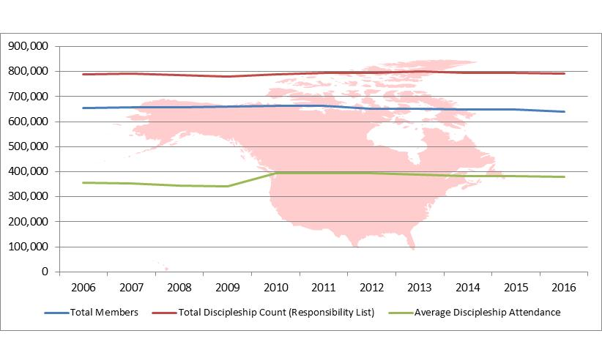

USA/Canada Region reports 33 different languages are used in its primary worship services.

QUADRENNIAL OVERVIEW: (Online version only)

- 543 new churches
- 104,217 new Nazarenes
- $146,573,497 (USD) given to WEF
- 203,379 conversions reported
- 78,253 baptisms
Analysis: The USA/Canada membership growth has been most pronounced in cross-cultural efforts. Hispanic, Haitian, and multicultural groups have all grown by thousands of members this decade. Discipleship efforts mirror the declining membership numbers.

Summary

The combined total of all regions indicates a global membership of 2.5 million (2,471,553).

There were nearly 600 thousand (559,615) new Nazarenes received into our fellowship in the past four years.

Additionally, there were 840 thousand (840,402) conversions and just under 362 thousand (361,619) baptisms administered.

It is important to note that 74.1 percent of our total membership is now located in global mission areas outside of the USA/Canada. There are currently 66 countries in the 10/40 window, considered to be the most Gospel-resistant and least-Christianized areas in the world. The Church of the Nazarene has work in 40 of those countries.

We have officially entered three new nations during this quadrennium: Curacao, Mongolia, and Singapore. We hope to announce more countries entered in the near future.

Jesus is Lord!

Churches and Districts

The Apostle Paul did not plant the big “C” Church in Asia Minor. He planted local churches in specific contexts.

We believe in the power of the local church. The Manual of the Church of the Nazarene states: “The local church, the Body of Christ, is the representation of our faith and mission” (Manual Preamble to Church Government). That is to say, we recognize that the Holy Spirit works from the bottom up, more than from the top down. Bishop Will Willimon aptly notes, “Jesus reserves his best work for the arena of the local church” (Willimon, Bishop, 143).

Some religious organizations focus on pre-evangelistic efforts; they plow the ground for Gospel seed to be sown. Other religious organizations focus primarily on evangelism, others on compassion, others on discipleship, and still others on church planting. These are all important aspects of the missio Dei, and the Church of the Nazarene strongly affirms and participates in all of these realms. However, the primary purpose of our global efforts, the end goal of our God called mission is HOLINESS CHURCH DEVELOPMENT – to plant and strengthen healthy, indigenous holiness churches everywhere.

The BGS has designated the definition of a church: “Any group that meets regularly for spiritual nurture, worship, or instruction at an announced time and place, with an identified leader, and aligned with the message and mission of the Church of the Nazarene may be recognized as a church and reported as such for district and general church statistics.”

To that end (and as of the writing of this report) in the past four years 2,964 new churches were organized, and 23 new districts were established, giving us a global grand total of 22,392 organized churches and 471 districts around the world. Additionally, we currently have 8,182 churches not yet organized in the pipeline – nearly 37 percent more churches moving toward organization! We celebrate these gains as evidence of the blessing of God and mission fulfillment.

The USA/Canada Region is seeing the beginning of a church multiplication movement. Regional Director Robert Broadbooks reports that during the period of 2012–2016 the region saw 653 newly registered churches, more than any other five year period since 1955–1959. These new churches totaled nearly 16,000 in morning worship, realized 7,104 conversions, and accounted for $28.5 million total income. A New Church Prayer Force, 2,000 strong, is praying for 10,000 new churches by 2030.

Ministers

Our pastors are some of the finest to be found anywhere. We continue to be amazed by the quality of Nazarenes that God is calling into the work. The Board of General Superintendents had the privilege of ordaining 3,060 women and men during the quadrennium, bringing the total to 17,848 elders and 820 deacons (18,668 total), with an additional 10,006 district licensed ministers. We also report 127 registered evangelists and 436 commissioned chaplains. We give thanks for these prophets, priests, and shepherds of the flock.

Global Mission

British missiologist Lesslie Newbigin famously distinguished between the “missionary dimension” and the “missionary intention” of the Church. The whole church is involved in the missionary DIMENSION (mission); but some are specifically called to oversee the missionary INTENTION of the church (missions). The missions task of the church is to take the gospel to places where it is not yet known. This “missionary spirit” has been vital to our connection from the very beginning.

In the last four years the General Board commissioned 41 new missionaries. This brings our total to 700 missionaries from 50 different nations including 253 Global Serve long-term volunteers. Additionally, there are 309 missionary children and 285 short-term volunteers. When we add 9,208 Work and Witness volunteers in 2016, there are currently 10,502 Nazarene missionaries and volunteers serving somewhere in the world. We are a “sent” and a “sending” church.

This is a different model of missions for some. New doors of opportunity require us to ask again: “What is a missionary?” The Board of General Superintendents has determined that “A Nazarene missionary is a disciple of Christ set apart by the Holy Spirit, prayerfully sent out by the church, and affirmed by Global Mission to cross geographic, cultural, and/or linguistic barriers for the purpose of incarnational engagement in God’s holistic transformation of all people.”

This definition stretches traditional understandings of a Nazarene missionary to include a growing number who feel called to missions work but, due to limited resources, may not be able to follow a conventional path. However, let us be very clear – ALL Nazarene missionaries, regardless of their status, receive support from the World Evangelism Fund and Global Mission. There is no such thing as a Nazarene missionary that does not benefit from our giving and our structure.

Recently I had the opportunity to sit with an apostolic leader in a Creative Access Area. He pastors the largest evangelical church in a city of millions. Drawn to the message of holiness he affiliated his congregation years ago with the Church of the Nazarene, teaching our Articles of Faith and using our Manual to organize their ministry structure. He said to me, “I have attended two general assemblies and was moved by the March of the Nations, when flags from the countries where the Church of the Nazarene has work are brought in. But I have also been sad, because my country was not represented. I dream of the day when my country will be counted in that march.”

This past February, in an historic moment of great celebration, prayer, and some tears, the BGS had the privilege of commissioning a new specialized district in that nation. With it came a flag … and that flag was carried in our March of the Nations this past Thursday night.

Jesus is Lord!

The missionary program of the church has evolved over 109 years, and undoubtedly will continue to do so. Adaptations must be made to changing opportunities, but be assured that any restructuring will hold fast to the core ideals of mission engagement and our commitment to being a holiness and Great Commission church. We cling to the promise of the risen Christ who says, “I have placed before you an open door which no one can shut!” (Revelation 3:7)

Finance

The World Evangelism Fund continues to be the lifeline of our global mission.

In an effort to strengthen our “lifeline,” the Board of General Superintendents sponsored a “Funding the Mission” study over the course of this past quadrennium. Portions of the 2015 and 2016 General Board sessions were spent in breakout sessions and discussion analyzing our funding model. The findings of this study were many, with several significant conclusions:

1. Funding is not about raising more money; it is about fulfilling the mission.

2. Personal connections are important. People give to more than causes; they give to people.

3. There is a lack of clarity about the current “missionary paradigm” and who is responsible for raising the World Evangelism Fund within the general church.

4. Nazarene beliefs about giving vary along generational lines.

As a result of that funding study, Global Mission Director Verne Ward and the Global Mission team (including a strong partnership with Nazarene Missions International) are working closely with the general superintendents to initiate and implement the Nazarene Missions Project. The goal is to reframe our missionary enterprise with special consideration given to the increasing interest in short-term missionary volunteers, the limitations of financial resources, and the need for greater unified communication to the entire church.
Our churches continue to be sacrificial with their giving. Nazarenes are a generous people. Total giving for the quadrennium amounted to $3.5 billion ($3,464,813,283). We say thank you for “excelling in this grace of giving” (2 Corinthians 8:7).

We need every church from every nation to be faithful in giving. Currently the USA contributes 95 percent of the WEF funding and 96 percent of mission specials. While we fully understand that global economies of scale can never be equal, sacrificial generosity must be. We call on Nazarenes everywhere to rededicate themselves to our shared commitment of global evangelization.

Ministries

All the ministries that follow are supported by and benefit greatly from your prayers and World Evangelism Fund giving. This is your report:

Nazarene Missions International

If the World Evangelism Fund is the lifeline of our mission, Nazarene Missions International is the mobilizing catalyst in the local church through praying, communicating, giving, and educating for missions support. We are thankful that as Nazarene missions continue to adapt for maximum impact, so is NMI at every level of leadership.

Nazarene Youth International

Nazarene Youth International (NYI) is a dynamic and vital aspect of our global family. There has been a great deal of research and discussion about the impact of millennials (those reaching young adulthood in the early 21st century) on the church and the impact of the church on millennials. Much of the data tends to focus on the negative aspects of their demographic. But in our frequent interaction with young Nazarene leaders, both pastors and laity, we are greatly encouraged by their love for the church and their commitment to the holy life.

Recent studies indicate that 94 percent of Christians came to faith in Christ between the ages of 4–30 (85 percent between the ages of 4–14). And yet, in 2016, 24 percent of organized Churches of the Nazarene reported having no “youth” in their congregation. Let that sink in ... 5,353 Nazarene churches did not have one single person ages 12–29. It is possible that this is only a matter of “counting,” but this should be of great concern to all of us.

Many lament the fact that some young adults are leaving the church, but many are also staying. Just as the church must ask why some are leaving, it is essential to discover why others choose to stay and then find ways to replicate those reasons in our local contexts.

Sunday School and Discipleship Ministries International

Becoming like Christ is our prayerful aim for every Nazarene. Our desire is to develop holy practices that will help our people grow in grace and shape the life of Christ in them.

We have heard a cry from around the world for a strong, cross-cultural discipleship curriculum to assist in the spiritual development of the thousands who are coming to Christ. The BGS has responded to that cry by creating One Lord, One Faith, One Baptism: Essential Teachings for Faith Formation in the Church of the Nazarene. This Nazarene catechism is a global initiative involving scholars and language committees from every region of the world. It is being released at this General Assembly in four languages, with plans for more to come. We believe this will be key to the faith formation of our people and we encourage every church to avail itself of this excellent discipleship resource.

International Board of Education

Nazarenes have stressed the importance of Christian education from the beginning. We have invested, often sacrificially, because we considered schools of higher learning to be an integral part of the faith formation of our children. In 1923, General Superintendent H.F. Reynolds said: “The sacrifice by faculty and students [in our schools] will go down in history as one of the great assets of our movement.” That prophecy has been fulfilled. Today the International Board of Education for the Church of the Nazarene has 52 colleges, universities, and seminaries in 35 countries with a total student population of approximately 52,000. We give God praise!

Nazarene Compassionate Ministries

The Church of the Nazarene is engaged around the world in compassionate, transformational ministry through Nazarene Compassionate Ministries (NCM). NCM exists to mobilize local churches everywhere to live out Christ’s call to care for “the least of these” in their communities. Over the past four years, NCM has supported the efforts of local churches and districts in responding to 40 natural disasters and emergency situations including the Ebola crisis in West Africa. More than 195 church-led development projects provided food security, clean water, sanitation, and hygiene. Additionally, efforts were made in economic development, health care, HIV and AIDS ministries, and work to lift up women and girls and to fight against human trafficking.

Over the past four years, more than 19,000 children have gained education, health care, life skills, and spiritual formation through 164 Nazarene child development centers in 37 different countries. Nearly 12,000 of those children are also receiving support through NCM’s child sponsorship program. Through support of Nazarenes around the world, these children are now connected to local Nazarene congregations.

Six years of war in Syria have destroyed communities and torn families apart. In that time, more than 11 million people have been displaced from their homes due to violence and persecution. Five million people have gone to other countries where they are now living as refugees.

While many only started paying attention to this refugee crisis in the past few years, the Church of the Nazarene has been engaged in caring for refugees since the crisis began. Since the war in Syria began, local churches in Jordan and Lebanon have regularly provided food and household supplies for more than 3,000 families living as refugees. Four Nazarene schools in Jordan and Lebanon have been providing education for more than 400 children displaced by the war in Syria. This was possible because Nazarenes around the world gave toward scholarship funds to embrace these children.

Many stories could be told, but Tarek’s story is emblematic. A young boy named Tarek fled from Syria to Jordan with his family. When he arrived he was extremely traumatized. One manifestation was severe speech problems and mumbling. He received a scholarship from a Nazarene school, where he found love, hope, and healing. Now he no longer mumbles, is healing from his trauma, has friends, and is doing well in fourth grade. In a recent letter he wrote these words: “I was destroyed from the inside out ... Thanks for the Nazarene school for helping me to feel that I’m still a human being.”

JESUS Film Harvest Partners

This year JESUS Film Harvest Partners (JFHP) is celebrating 20 years of transforming hearts and lives around the world. Since this initiative began, JESUS film has reached a milestone of 14 million decisions for Christ. Of those 14 million, 22 percent were in the last four years – 3 million conversions! Since 2013 JESUS film teams have done 118,895 presentations, allowing nearly 13 million to view the film. Over 2 million people have received discipleship follow-up.

Nazarene Publishing House

Nazarene Publishing House (NPH) has served our church for 105 years and continues to be the world’s largest publisher of Wesleyan-Holiness literature. After facing some operational and fiscal challenges, NPH has made great strides toward regaining financial stability. Actions to stabilize the company and the launch of new products have resulted in operating income in the black over the last two years. The BGS expresses deep appreciation to the NPH staff and board for their extraordinary contribution in helping reposition Nazarene Publishing House toward a new day.

With a primary focus to serve the Church of the Nazarene, NPH will, in February 2018, rebrand itself to the wider Wesleyan-Holiness community as The Foundry Publishing — a place where faith is forged.
Recommendations from
Board of General Superintendents

I count it a personal privilege to work alongside five highly motivated, uniquely gifted, Spirit-led servant leaders. They have become more than colleagues — they are friends.

Our board will miss the strong, perceptive, and creative leadership of Dr. Jerry Porter and Dr.
J. K. Warrick. Their combined 32 years of service in the general superintendency has been a gift to the entire church. We owe them a debt of gratitude for their enduring legacy of a compassionate missionary spirit and courageous pastoral wisdom.

It has been our joy to work with an outstanding Global Mission Team, regional directors, field strategy coordinators, district superintendents, educational leaders, pastors, and Spirit-filled laypersons who love the message and mission of the Church of the Nazarene.

The request of the 2013 General Assembly to study the Future of the General Superintendency has been fulfilled in this quadrennium. We express our deep appreciation to General Superintendents Emeriti, Drs. Jim L. Bond and Jesse C. Middendorf, for leading a task force to consider this important issue. Our full report, with conclusions and recommendations, was presented this past Saturday in the delegate orientation.

We strongly affirm the need for the general superintendency to remain as one of the three visible reflections of unity in the International Church of the Nazarene, along with the General Assembly and General Board; that ordination and global itineracy are integral to the role of a present and future general superintendency; and that the projected growth of the denomination only increases the need for an incarnational jurisdictional presence of the general superintendents.

And so we prayerfully and humbly submit the following in service to the church:

Recommendation No. 1: Nazarene Essentials

In his quadrennial address to the 1923 General Assembly, H. F. Reynolds stated: “We represent many shades of belief along the line of non-essentials … There are many differences of opinion among us, but thank God, we are united to essentials.” At that time the membership of the church was 53,000. Much has changed since then. Fully one-third (approximately 800,000) of our membership has come in the last 10 years. Every region requested basics of our church’s teaching, history, theology, mission, funding, and interdependent connections to be provided in a brief and easily understood and accessible publication. The BGS introduced Nazarene Essentials in 2014 in order to help the church understand “who we are” (identity) and “what we do” (mission). The response has been overwhelmingly positive from pastors, educators, and laypersons alike. We are pleased to hear that Nazarene Essentials is being used in a variety of ways to strengthen our churches. Thanks to the diligence of our translation teams, it is now available in 33 languages with others on the way.

Recommendation No. 2: Articles of Faith

With the great cultural diversity of the Church of the Nazarene, we must have a theological center. To be decentralized in our mission requires that we be centered in our beliefs. Some have described the varied theological expressions of our Wesleyan-Holiness tradition as being a “big tent.” While we understand this phrase to mean that we focus on the essentials of our faith, while allowing greater freedom regarding non-essentials, the image begs the question: “Who decides the size of the tent?” One person’s version of a “big tent” may be significantly larger than another person’s version.

The Church of the Nazarene has determined that our Articles of Faith are the centering point, anchoring the church in the midst of ever-changing philosophies and beliefs. Therefore, any changes to the Articles of Faith must be done with prayerful and prudent discernment.

The 2013 General Assembly voted that the BGS appoint a group to study various Articles of Faith over the quadrennium. Composed of some of our finest theologians and pastors, the study group met on several occasions to thoroughly review and recommend revisions. We have received their work; and after careful examination, we believe that the revisions strengthen the Articles, and we are recommending them to the General Assembly for adoption. We want to be clear that these resolutions are not a redefinition of our doctrine, but a restating of it for greater clarity. The Articles of Faith have been translated into 44 languages, with two more in the final process.

Recommendation No. 3: Human Sexuality and Marriage

The BGS appointed a global group of Nazarene theologians, ethicists, pastors, psychologists, and counselors to study our Manual statements, prepare a position paper, and propose legislation on human sexuality from a Wesleyan-Holiness perspective. The Covenant of Christian Conduct Study Committee was composed of thirteen people with representation from every region of the church. They met face-to-face numerous times and corresponded frequently by video conference and email. Their work was thorough, diligent, and at times difficult. Conversations about human sexuality are some of the most important and challenging the church faces in this generation. And yet, these conversations were “full of grace and truth.” The BGS has received their work with gratitude and wholeheartedly commend it to this General Assembly with our full support.

Because every word of the legislation has been carefully vetted, and to change any part can nuance the meaning of the whole, we request the General Assembly to consider adopting the legislation as a whole, or to reject it, without editing from the assembly floor.

When it comes to ethical issues such as these, cultural norms are not our guide. Scripture, orthodoxy, and the Spirit of Jesus must lead. If Scripture does not challenge us at places where the culture is doing its best to squeeze us into a different pattern, what good is it? If Scripture is not authoritative in our lives in ways that make us feel uncomfortable and occasionally out of step with accepted cultural practices, is it really God’s Word? Is Jesus really Lord?

Whatever we decide to say about these important issues as a denomination, let us say it with the tone of perfect love and let our actions be extended with a generous hospitality befitting the people called Nazarenes.

Recommendation No. 4: Urban Ministry

Historian Rodney Stark states “All ambitious missionary movements are, or soon become, urban” (Rodney Stark, Cities of God). The Board of General Superintendents has a growing sense of urgency for the work of the church in the urban context. The World Health Organization projects that by 2030, six out of every ten people will live in a city; and by 2050 this proportion will increase to seven out of ten people. These projections will double the global urban population to 6.4 billion people. The Asia-Pacific Region of the Church of the Nazarene reports 153 cities over one million with a Christian witness of 5 percent or less.

The most common urban ministry strategies for the Church of the Nazarene have concentrated on compassionate ministry centers and ethnic congregations. While these continue to be valid models, they cannot be the only approaches to address the intricacies of an “urban world.”

For urban strategies to be successful we must learn to lead with mission rather than structure. With the help of Global Mission, we have already convened several urban consultations and forums to begin this important discussion. More are being planned. Every region has identified ten megacities to begin or extend missional focus. We will continue to make this an area of concentrated prayer and strategic emphasis. This does not mean we should, or will, ignore rural areas or suburbs. The whole world is our parish, but as Timothy Keller aptly says, “As cities go, so goes the world.”

Phineas Bresee famously wrote in his journal, “It had been my long cherished desire to have a place in the heart of the city, which could be made a center of holy fire, and where the gospel could be preached to the poor.” Join us in praying for centers of holy fire in every city of your region.

Recommendation No. 5: Vision 2020

While we continue to grow, the last quadrennium has not seen the same pace of growth as recent years. What should we do? Should we reset the vision? Should we step back and recalculate? Or can we ask our Lord of the “immeasurably more than we can ask or think” to help us see what He sees? Can we see expanding fields ready to be harvested, only lacking for more workers?

The first step is to plan for Vision 2020 faith projections that the church may reach 3.5 million total members, with 2.5 million in worship attendance, 2.5 million in discipleship attendance, in 50,000 churches. Every region has embraced this vision, and many hundreds of churches and dozens of districts have asked God to do something in our generation that we have never seen before.

This will require a renewed emphasis of intentional holiness evangelism. Sound doctrine will not be enough. Well planned worship services will not be enough. Sacramentalism will not be enough. Compassion will not be enough. Social justice will not be enough. We will need a new heart that integrates both Word and deed – Gospel and action.

Habakkuk reminds us to “Write down the vision and make it plain on tablets so that a herald may run with it. For the vision awaits an appointed time ...” (Habakkuk 2:2 NIV)

A Movement of God

Can we become a movement again?

We are living in unprecedented times. There are seismic cultural shifts affecting every continent on earth. In just two decades we have seen the shift from industrial to information – from Gutenberg to Google; from rural to urban; from modern thinking to post-modern thinking. It is a hinge of history that our grandparents and those before them could never have imagined. We will not return to what once was.

Whether we are comfortable with it or not, we find ourselves in a pivotal time for Christianity. We are in mostly uncharted waters. We appreciate the legacy of John Wesley, but Wesley alone will not do. We are grateful for the vision of Phineas Bresee, but Bresee alone will not do. We have to go back to the first Nazarene. We have to go back to Jesus. He is our calibration point. We correspond to Him. We realign to Him. We must re-Jesus the church. Too much is at stake for anything less.

The seed of the future is in the womb of the present (Hirsch). Not every seed will become a forest, but it can be. Not every spark will become a forest fire, but it can be. The potential is in the seed and the spark. And so it is for the Church of the Nazarene. The seeds of our future are in the womb of the present. The spark of a raging fire is in the soul of the church.

The year was 1944. World War II was raging. In one of the most precarious and uncertain times of the twentieth century, General Superintendent J. B. Chapman spoke these words to the General Assembly: “As a people, we love fire and cannot be content with smoke … Our church is a mechanism that can stand only while it moves forward. To stop is to fall… More self-preservation will mean stagnation for us. Our hope is in aggression. Our church is a force for which the whole world is a field.”

This kind of movement thinking will require a radical discipleship at every level of the church. It will require us to make mission our organizing principle. It will require us to change whatever keeps us from being fully surrendered to the will and purposes of God. It will require us to believe that Jesus really is Lord and to have the strength and courage to act on it.

Nazarene Essentials are helpful but not enough. Thankfully we have THE Nazarene essential – Jesus is Lord! And we are not afraid. We are radical optimists of the grace of God and “prisoners of hope” (Zechariah 9:12 NIV).

Hope has a Name.
He is Emmanuel – God with us.
He is the Lamb of God who takes away the sin of the world.
He is our Great High Priest.
He is our Deliverer.
He is the Light of the World.
He is the Chief Cornerstone.
He is the Head of the Church.
He is faithful and true.
He is the Alpha and the Omega.
He is the Resurrection and the Life.
Jesus is the King of Kings and Lord of Lords.

“To Him who sits on the throne and to the Lamb be praise and honor
and glory and power for ever and ever!” (Revelation 5:13, NIV).

Prayerfully and respectfully submitted,

Board of General Superintendents
Church of the Nazarene

Jerry D. Porter
J. K. Warrick
Eugénio R. Duarte
David W. Graves
David A. Busic
Gustavo A. Crocker

bgs@nazarene.org

