BIOS
Tod Bolsinger

Tod Bolsinger joined Fuller Seminary in 2014 as vice president for vocation and formation and assistant professor of practical theology, and he now serves as vice president and chief of leadership formation. Ordained in the Presbyterian Church (USA) in 1993, Dr. Bolsinger served as senior pastor of San Clemente Presbyterian Church from 1997 to 2014. Prior to that he was associate pastor of discipleship and spiritual formation at First Presbyterian Church of Hollywood.
Holding both a PhD in Theology and Master of Divinity from Fuller, Bolsinger taught graduate-level classes in theology for 14 years at Fuller’s regional campus in Orange County prior to joining the seminary’s regular faculty. He has extensive experience in church and nonprofit consulting and executive coaching, and writes infrequent weblogs on church and leadership formation. His faculty role at Fuller includes teaching the Practices of Vocational Formation class and a cohort in Leading Change for DMin students.
Bolsinger has authored three books, It Takes a Church to Raise a Christian: How the Community of God Transforms Lives (Brazos, 2004), Show Time: Living Down Hypocrisy by Living Out the Faith(Baker, 2005), and Canoeing the Mountains: Christian Leadership in Uncharted Territory (IVP Books, 2015). Bolsinger has also written a chapter about building community in a virtual world in the book The New Media Frontier: Blogging, Vlogging, and Podcasting for Christ (Crossway, 2008) and contributes essays and articles to journals in the areas of leadership, spiritual formation, leadership formation, and innovation.

L. Gregory Jones
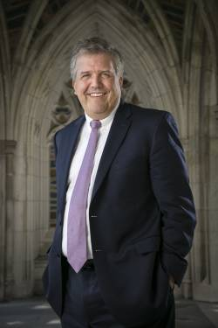
Dean of Duke Divinity School and Ruth W. and A. Morris Williams Jr. Distinguished Professor of Theology and Christian Ministry

Professor Jones is a dean and a theologian whose work centers on the nature of forgiveness, the significance of Christian ministry and pastoral leadership, and social innovation and entrepreneurship. He has served as Duke’s chief international strategist to advance and coordinate the university’s global engagement. Between 1997 and 2010, Dr. Jones served as the eleventh dean of the Divinity School.

The author or editor of seventeen books, he has also published more than 200 articles and essays. His most recent book is Christian Social Innovation: Renewing Wesleyan Witness (Abingdon Press, May 2016). He coauthored the book Forgiving As We’ve Been Forgiven with Celestin Musekura and another book with Kevin R. Armstrong, Resurrecting Excellence: Shaping Faithful Christian Ministry.

“Traditioned Innovation.” A way of thinking and being that holds the past and future in tension, not in opposition, is crucial to the growth and vitality of Christian institutions. L. Gregory Jones explains the phrase he coined.

“In businesses and other organizations, including Christian ones, the traditionalists are so stuck in their ways that they drive reasonable people toward change for its own sake. People obsessed with change create such chaos that reasonable people long for some form of stability. And so the pendulum swings between traditionalist strategies and innovative ones, causing organizations and leaders, people and cultures, to suffer.
It is a return to Christian thinking that offers the best way forward.”

LINDA SEAMAN
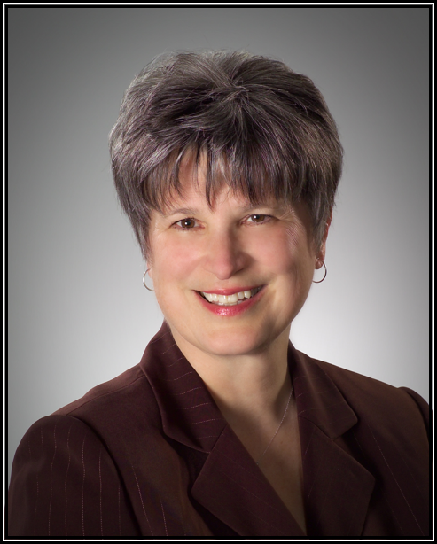

Linda Seaman is a graduate of Olivet Nazarene University, where she earned a B.A. in English and later received an honorary doctorate. She taught for several years in Olathe, KS, and continued to use her gift of teaching throughout her life in both academic and ministry settings. Linda and her late husband, Dr. John Seaman, were commissioned by the Church of the Nazarene in 1976 to serve as missionaries in church planting and leadership development. They were then appointed to Martinique in the French Caribbean, where they developed the work of the church over the next ten years. The Seamans then accepted an assignment in 1986 to pioneer the work for the Church of the Nazarene in West Africa. Based in Abidjan, Côte d’lvoire, they oversaw the work of a growing and dynamic region over the next 17 years that now comprises more than one thousand churches and 100,000 members. After nearly three decades of missionary service, her husband was elected superintendent of the Michigan District Church of the Nazarene in July of 2003 where, together, they served in that capacity over the next 14 years. Linda has had the privilege of speaking at several conferences and events throughout her life and passionately believes in, and communicates, the power of God’s Word to transform lives. The transformation she proclaims and practices is holiness of heart and life. Linda has held a variety of leadership positions both overseas and in the United States. She served as school board president of the International Community School of Abidjan, and helped lead a new interdenominational crisis response initiative for missionary care and counseling. Additionally, she has served her denomination on the International Church Commission, the board of Helping Hands, Healing Hearts, as well as the General Church Women’s Ministries Council. She is mother to three married children and loves nothing more than spending time with her ten grandchildren. Linda is an avid reader, appreciates a clean house, and, because she’s Irish, loves to worry. She currently resides in Nashville, TN.

